December 18th, 2011
Hi
I mentioned that last Sunday was election day to chose the members of the committee that will choose the next CE. There was only a 27% turnout of eligible voters. The non-democratic camp got about 200 electors, a surprisingly large number, and more than the 150 needed to nominate a CE candidate. But still, the person who is likely to win got many more. Still, having at least two candidates for CE will force a public discussion and debate on issues. For the earlier District Council elections, the information sent to me from the electoral office arrived the other day - about 6 weeks late!
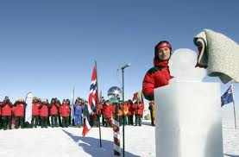
Last Wednesday, 14 December 2011, was the date 100 years ago when the Norwegian explorer Roald Amundsen became the first person to reach the South Pole! The Norwegian prime minister was at the South Pole for the occasion (only the second world leader to have been there, the other being Helen Clarke, the former NZ PM). While there, he unveiled an ice statue of Amundsen (see photo).
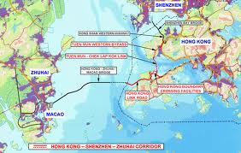
On the same day, work began on the 50 km HK-Zhuhai-Macau bridge, nearly a year late due to legal challenges based on environmental issues. It will start near the airport and cross the mouth of the Pearl River towards Macau where it will fork, with the other arm going to Zhuhai in China.
The run yesterday was not bad - from Tai Po to Tai Mo Shan then to Sek Kong (through the forest - where I had the bad spill a few years ago and permanently dirtied your 'Millenium cap'!). At 2 h 48 mins, it was about 11 minutes slower than my best, but I take the forest part slowly now to avoid another spill. But even the other legs were a bit slower - age creeping up on me! Although I had only had about two hours sleep the previous night, I don't think that affected the run. In the evening, on Aus TV, I saw the final 20 minutes of the Sydney 'Carols in the domain' - about 80 000 attending. (Last year I watched the whole thing.) They put on a pretty good show.
In this letter last year (and exactly the same date), I mentioned about the asylum boat tragedy on Christmas Island, an Australian territory far from Australia but very close to Indonesia, when a smuggler boat was caught in a severe storm and dashed against rocks on the island, killing or drowning many on board. Well, just heard on the news of a similar disaster but this time closer to Indonesia; a similar boat with refugee seekers was caught in a storm yesterday and sank. This follows a similar incident a few months ago.
That’s about it for now.
Cheers

